**CELL0009 Cell Structure and Function**

**COURSEWORK “C”**

**ANALYSIS OF DIGITAL FLUORESCENCE MICROSCOPY IMAGES – In-Person Computer Practical**

**Introduction**

***Fluorescence microscopy:***

A key technique in cell biological research, fluorescence microscopy enables you to identify the subcellular location of both endogenous and exogenous proteins using fluorophores (fluorescent molecules). Upon excitation with light at a specific wavelength, fluorophores absorb the light energy and re-emit light at a longer wavelength. This phenomenon is called **fluorescence**. The emitted light is detected by a sensitive device (camera or photodetector), which picks up the photons and converts the light signal into an electrical signal that is recorded by a computer. The resulting **digitized image** provides both qualitative (where the signal is, i.e., where the protein is in the cell) and quantitative (how bright the signal is, i.e., how much protein is in a particular place) information, which can be processed for further analysis.

***Tools to label cells: antibodies vs fluorescent proteins vs dyes:***

Endogenous cellular proteins can be detected and localized using fluorescent **antibodies** specific to those proteins, a technique called **immunofluorescence**. The protein of interest can also be expressed in the cells as an exogenous protein tagged with **green fluorescent protein (GFP),** after transfection with a plasmid carrying the DNA sequence**.** GFP is **fluorescent** and thus the tagged proteincan be detected without using antibodies. Some fluorescent dyes also stain specific organelles in the cells enabling their visualization, such as the mitochondrial markers **rhodamine123** or **MitoTracker** (which fluoresce red).

***Co-localisation:***

Samples, which are usually cultured cells, can be **double-labelled**. This means that a protein of interest can be identified using a fluorophore emitting one colour (e.g. green), and a protein or dye with a known intracellular distribution, often called the “marker”, can be labelled with a fluorophore emitting a different colour (e.g. red) within the same cell.

If the protein of interest (**green**) and the signal with a known distribution (**red**) are found in the same place, then they are said to be “**co-localised**” and the resulting colour observed is the overlap of both fluorophores (e.g., **yellow**). This is often used to determine if a particular protein is localized to a specific organelle or if it colocalises with another known protein in the cell. The **co-localisation** can be with another endogenous immuno-labelled protein, with a GFP-tagged exogenous protein or with an organelle-specific marker.

***If you have colour blindness or any other visual impairment, please ask the tutors for assistance who will be very happy to help. We have also provided additional files to help with interpreting the images – please see the information below.***

**Aims**

The aims of this “dry” fluorescence microscopy practical are: 1) to get used to looking at and interpreting fluorescence images, 2) to get a feel for the nature of the digital fluorescence image, and 3) to explore the possibilities of quantification presented by the digital image. These aims will be achieved by looking at a series of fluorescence images, selecting particular areas (128 x 128 pixels), and quantifying the proportions of the image (i.e. number of pixels) selected that are green (protein of interest), red (intracellular marker) and yellow/orange (co-localisation). From this the percentage distribution of the protein of interest (green) can be determined.

**Images that you will be analysing**

You will be assessing 3 fluorescence images. For ease of reference throughout this practical these images are termed IMF 1, 2 and 3. They are taken from a series of experiments in which cultured COS cells (a SV40 virus-transformed cell line derived from green monkey kidney) have been transfected with cDNA encoding 1 of 3 different GFP-tagged test proteins with unknown subcellular distributions. Note that the transfection efficiency is much less than 100%, so not all cells in the cultures will actually express the fluorescent protein. The cells are also labelled with MitoTracker (red), which is a fluorescent dye that specifically labels mitochondria. The purpose of the experiments from which the images were taken was to determine whether the test proteins localise to mitochondria. IMF 1,2 and 3 show the distribution of test proteins 1, 2 and 3 respectively.

**Important information about colour blindness:**

Colour vision deficiency (CVD or colour blindness) is thought to affect up to 5% of the UK population and is more common in males. For individuals with certain forms of CVD, distinguishing between green and red colours can be very difficult or impossible. Therefore, especially in recent years, the scientific community has been heavily encouraged to represent microscopy images in colour combinations that are distinguishable for individuals with CVD, such as green and magenta.

Unfortunately, since this practical requires the use of red and green colour channels for the computer to separate the colours, we are unable to change the colour of the images used for the analysis. However, all steps in the practical can still be followed by individuals with CVD, and we have provided “colour blind accessible” versions of the images to help with visual interpretation:

* **In these alternative versions of IMF1, 2 and 3 the red signal representing mitochondria has been replaced with magenta (pink), and colocalised signal appears white instead of yellow**. These can be used to help with visual interpretation of the localisation of the **test proteins (which remain green)**.
* Note that these converted images CANNOT be analysed using ImageJ since the colours have been changed, causing overlap between channels which need to be separated based on their red and green pixel values. Therefore you should **only perform colocalization analysis using the original, unmodified images.**

**Reading instructions during the practical**

You may find it easier to read instructions from a laptop or tablet if you have one, or print the instructions beforehand and have them alongside the computer screen (since we will not be providing printed instructions).

**Software**

Three computer programmes will be used during this practical; their functions are:

1) **ImageJ**. Visualisation of IMF colour images of double-labelled cells. Selection of the 128 x 128 pixel areas in the images to be analysed. The selected areas are output as a colour image. Splitting colours in the selected area into individual colour (red and green) channels. At this point, you will now be working with greyscale images, which means when the two colours (i.e. the two fluorophore distributions) are split they display as separate black and white images. Save the separated images in TIF format as well as export as text files. As text, each pixel is given a value from 0 (black) to 255 (white). The value given is proportional to the intensity of the original individual colour within the IMF image. In other words a value of, say 0 ‘green’ for pixel coordinate 1,1 would mean there is no green (i.e. none of the test protein) is localised in that pixel, but a value of 255 would mean a lot is localised in that pixel. And so on for each of the 16, 384 pixels that make up the 128x128 selected area. Because each pixel coordinate is the same for each split image, what you end up with is information on how much (0-255) ‘red’ and how much (0-255) ‘green’ you have in each of the 16, 384 pixels. Thus, any individual pixel that contains both colours (test protein colocalises with mitochondria) will appear yellow/orange for that pixel in the original colour image.

2) **Microsoft Word**. Takes the text files generated by ImageJ and modifies them so that they can be read into the Excel calculating template. Basically this means replacing all tabs with manual line breaks.

3) **Microsoft Excel**. This is the program that carries out all the calculations (i.e. works out the cellular distribution of the fluorescent proteins/markers). The Word-generated text files are copied-and-pasted into the Excel template. The spreadsheet will calculate the total number of pixels that contain each “colour”, give a % distribution and create a scatter plot of pixel colour distribution.

**Location of data files**

All images to be analysed and the Excel calculation template should be downloaded from the CELL0009 Moodle Coursework C section at the start of the practical. These are packaged as a .zip file “Coursework C Practical Files”. You should create a new folder in your (N:// Home) drive and extract the files to here.All the files you generate during the method should also be saved in a separate folder in your (N://) drive, see “Saving Files” below.

The files required for the practical are:

Three IMF image files, “**IMF1”**, “**IMF2”** and “**IMF3”**. They are all in PNG (.png) file format.

The Excel calculation template file called “**IMF Calculation Template.xls”**.

(*Optional*) Colour blind accessible images for viewing only (NOT for analysis).

All programmes (ImageJ, MS Word, and MS Excel) can be found via the “Windows” icon and the search function within the lab.

**Saving files**

Make sure that you save all your files as you go along, **using appropriate and new filenames**, so that if you make a mistake, you do not need to go back to the start. Also, if you save your files as per the following instructions, then you can work on them on your own after the practical has finished.

To find where to save your files, do the following:

Logon to UCL and use your personal UCL disk space (use the “Windows” icon and select “computer”. Your own central UCL drive (N:// Home) should now be visible for saving.

Give the folder an identifiable name (e.g. “CELL0009 practical” and “your name”).

All the new files you generate during this practical should be saved to this folder.

When you have completed the practical ensure that all of you work and the final calculation sheet used to analyse each individual image are saved to your UCL disk space.

**METHOD**

These instructions assume that you are familiar with using MS Windows, and that you understand the nature of the digital image (i.e. computer-generated images are not continuous tone images but are instead made up of pixels, each with a particular intensity and colour).

i) Open **ImageJ app** and **Word** using the “Windows” icon or search function in the taskbar at the bottom of the screen.

ii) Open **IMF Calculation Template.xls** in **Excel** ready for when you reach that part of the method.

iii) Minimise all programmes except **ImageJ**

**You will find it easier to follow the method if you refer to the screenshots (at the end of these instructions) as you go along.**

**A) ImageJ**

In ImageJ open all three IMF image files [**IMF1.png ...**etc]. Have a look at them; zoom in and out to get a feel for the digital image and its resolution; take note of the similarities and differences between the images. Copies of the IMF images are also at the end of these instructions. If you have CVD, you may wish to visually compare the colour blind accessible images at this point. Close all image files but leave ImageJ open.

The IMF images are RGB (i.e. red, green, blue) images. However, because the cells were only double, not triple, labelled the blue channel will contain nothing (i.e. it will be almost black). During the original IMF experiment each colour channel (i.e. red and green) was captured separately. The separate channels were then merged to give the complete coloured image. However, because we want to determine localisation by determining how much green, red or yellow/orange is present in the image, the colours must be separated into their original channels.

1. Open one of the IMF images.
2. Select “Rectangle” from the left-hand side of the ImageJ tool bar (***see ImageJ screenshot for location of tool***).
3. Press ‘Edit’ > ‘Selection’ > ‘Specify’ and type 128 for the Width and 128 for the Height, but ignore the X coordinate and Y coordinate values. You should now have a box with a yellow online that is 128x128 pixels in size. Press OK**.**
4. By pressing and holding the left mouse button in the box, move it to the area you want to analyse.
5. When you are happy that you have selected the area you want, Press ‘Image’ > ‘Crop’ to gain just the 128x128 selection.
6. Press ‘File’ -> ‘Save’ to save the crop images in TIFF format and add ‘RGBcrop’ to the beginning of the file name (e.g. RGBcropIMF1.tif). **Check the save location and make sure to save all files in a memorable folder location in your personal (N:) Drive**, since the default save location is sometimes an inaccessible system folder which prevents you from retrieving your data.
7. In the options press ‘Image’ > ‘Color’ > ‘Split Channels’. This will give you three images red, green and blue. Press and hold the left mouse button at the side of each image window to make it bigger so that you can read the full filename that includes the colour in brackets bar (***see ImageJ screenshot that show the filename***). You do not need the blue image, so close this.
8. Press ‘File’ -> ‘Save’ to save the red and green images in TIFF format (the default filename should automatically include the channel colour, so leave this unchanged).
9. For both the red and green images press on each image before pressing ‘File’ > ‘Save As’ > ‘Text Image…’ to also save the images in text format (TXT files).

# B) Word

Within Word, open the red and green **TXT files** (you might first need to change file type to “all files”). Next, we need to make sure all the numbers you see on the page (corresponding to pixel values) are in a single column rather than a grid so that we can transfer these values to Excel. To do this, we use a method to replace all tabs with manual line breaks.

Use the “Replace” function found within the “Editing” section in the top right corner of the “Home” toolbar and follow these instructions:

* For “Find what”: type the shortcut “**^t**” or click “Tab Character” (via the “More >>” and “Special” menu)
* For “Replace with”: type the shortcut “**^l**” or click “Manual Line Break” (via the “More >>” and “Special” menu)
* Press “Replace All”.

If you have performed this step correctly, there should be 16,256 replacements. (NB: Look at the screenshot section to see what effect all this has on the numbers representing the pixels before and after doing the replacement).

Repeat this step for the remaining colour file.

# C) Excel

For each Word file in turn “Select all” (Press “Select” drop-down menu then “all” in the “Editing” section in the top right corner of the “Home” toolbar ) and “Copy” (left side of toolbar) to clipboard, then paste (left side toolbar of Excel) into the **IMF Calculation Template** in Excel (only do one at a time as the clipboard can only deal with one file at once). Each will take about 10-20 seconds. Paste the red file into the red cell and the green file into the green cell (see Excel screenshot). The red and green data will be tabulated in columns C and B, respectively, starting in row 34.

Press F9 to begin the calculation in Excel (this may take several minutes). (*Note: progress can be monitored by viewing “% complete” at the bottom left of the screen*). All the calculations take place in rows 34 - 16417. A square of 128 x 128 pixels contains a total of 16,384 pixels - therefore a lot of calculations have to be carried out. The logic of the calculations can be understood (by those with curiosity) by clicking on the various cells between D34 and M16417. The thresholds are set by default to 50 but they can be altered. (*Note: keep your hands off the keyboard and mouse while the calculation is taking place, as any other input could reset the calculation*).

**NOTE in some versions of Excel, you do not need to press F9 and the calculation runs automatically.**

The logic of the calculation is as follows:-

If the red value for a pixel <50 and the green value <50, then the pixel is black.

If the red value for a pixel =/>50 and the green value <50, then the pixel is red.

If the red value for a pixel <50 and the green value =/>50, then the pixel is green.

If the red value for a pixel =/>50 and the green value =/>50, then the pixel is yellow.

After the calculation, the total number of pixels that are red, green, yellow or black is shown at the top of the spreadsheet. The distribution of the test protein is calculated not only from the number of pixels containing green that either do not contain red (i.e. green pixels) or do contain red (i.e. yellow pixels), but also from the green intensity of each pixel (i.e. a value between 0 and 255). Pixel intensity is assumed to be proportional to the intensity of the fluorescence emission in that pixel, which in turn is assumed to be proportional to the amount of test protein. Therefore, by summation of the total number of green and yellow pixels multiplied by the intensity value of green in each pixel, we can obtain an estimate of the actual amount (as a percentage of total) of the test protein that either co-localises with the marker (yellow) or does not co-localise (green). This percentage distribution is also shown at the top of the spreadsheet after the calculation has been completed.

After the calculation, a scatter diagram is plotted which shows the red values and green values for each pixel. Although the threshold value is subtracted for the calculations, it is not subtracted for the scatter plot.

In order to remind you of what the original 128 x 128 pixel colour image looked like, do the following:

In ImageJ open your cropped selection (the 128 x 128 RGB JPG image) that you should have saved at the start of this piece of this exercise.

Press ‘Edit’ > ‘Copy to System’ to copy the image to the clipboard.

Return to your Excel template and “Paste” the clipboard into the marked square at the top of the spreadsheet. You can resize it to make it look better. Write the name of the image you analysed in cell B1 (e.g. “IMF1”) and your name in cell E1.

Save the spreadsheet with a unique filename e.g. “(Your name + image name).xlsx” in your folder for this practical. (**NB: Make sure you use “Save As” rather than “Save” so that you do not overwrite the original Excel calculation template file**).

After you have completed an Excel template for one IMF image, you also need a copy of the first page of your results. Ensure the “Filename” and “Student name” fields are filled in correctly, then either:

i. Save your results as a .pdf file (by using the Export function in Excel). Select cells A1 to N36 by dragging the cursor. Under “File” press “Export” and “Create PDF/XPS” and “Publish” (i.e. save) this in your folder, naming the file according to the image analysed.

Or…

ii. Use the ‘snipping tool’ (use search function at the bottom of the screen to find the app) to snapshot a copy of your results. Save the screenshot with suitable file name (so you can identify whether it was analysing IMF1 etc.) to your N:// drive folder for this practical.

**Now repeat ALL STEPS for the remaining two images:** once you have completed your processing of one image file and saved all your results, make two more copies of the excel spreadsheet and repeat the whole method on the 128 x 128 pixel areas selected from the two other image files. Make sure to save a copy or screenshot of your final results for each IMF file.

Finally, proceed to the next page for instructions on how to complete the practical.

**Completing your work and gaining credit:**

**Fill out question 1 (coursework C, interpretation below) and** **find a PGTA or staff member to discuss your results and obtain feedback. Then do the following:**

1. Once you have discussed results, please sign the second column of the register available in class. Please note that unless you are recorded as having the laboratory classroom work completed successfully by a class organiser/demonstrator before you leave the lab your grades will not be recorded. It is your responsibility to ensure that this is done and records are taken.
2. In your own time, complete the Moodle quiz for the practical. Your grade will only be recorded after the quiz closes IF you have signed the attendance sheet AND signed that the practical is complete.

**Coursework “C” INTERPRETATION**

Considering your results from the Excel templates, answer this question and discuss with staff/PGTA:

1) What percentage of each test protein co-localised with mitochondria?

IMF1 = IMF2 = IMF3 =

2) Discuss with a tutor what you might do differently on this practical if you had more time allocated in the lab.

**Images: original version**

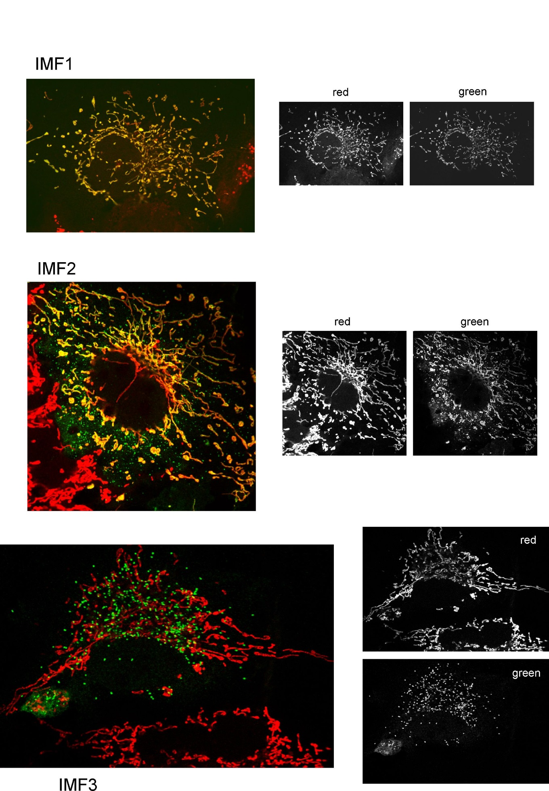

**Images: colour blindness (CVD) accessible version**

magenta

magenta

magenta

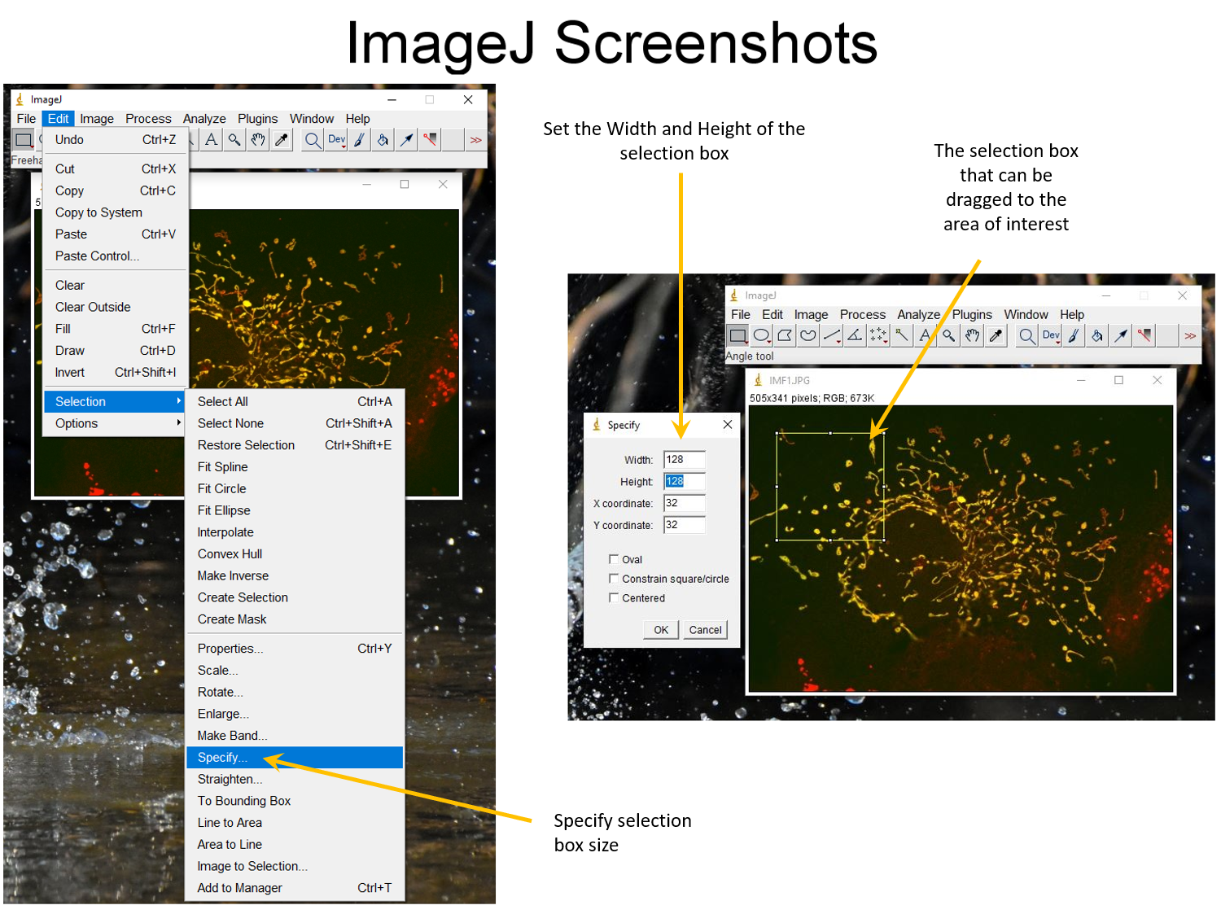 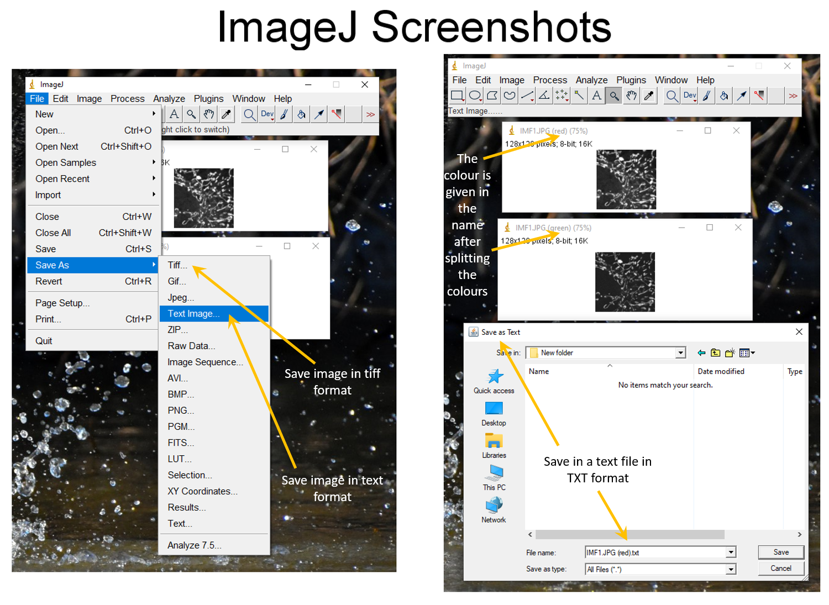

**WORD Screen Shot- This is what Word should look like when you open the text file that you had previously created in image J**

